CENTRALIZED PENSION MODULE

1.LOGIN PAGE
ENTER USER CREDENTIAL
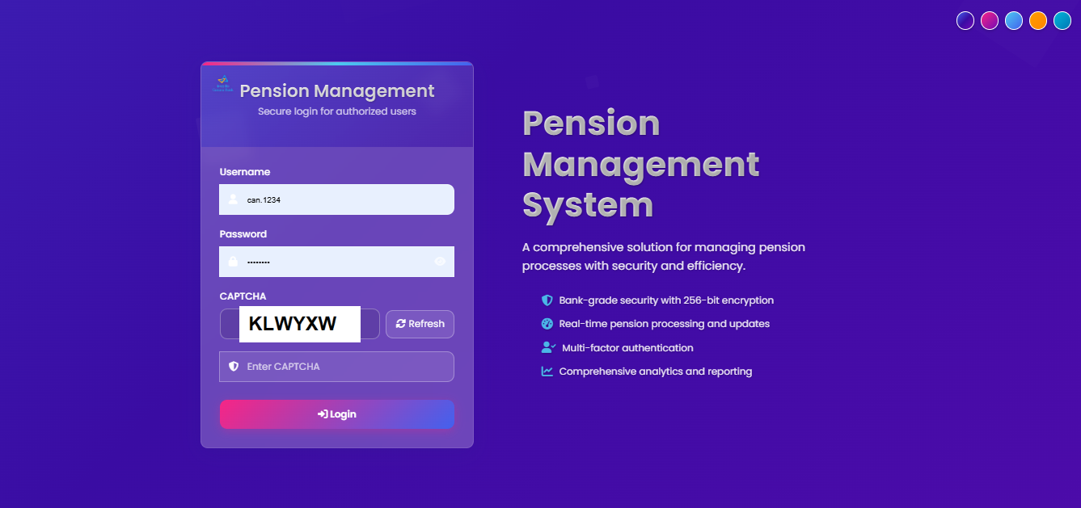

2. DASHBOARD
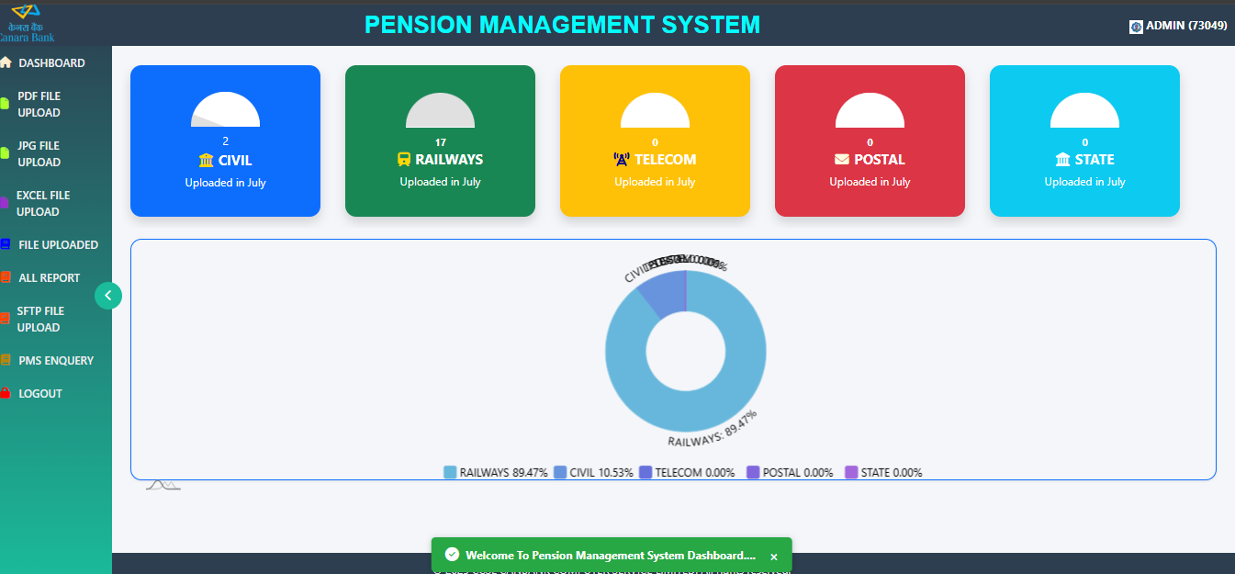
IN DASHBOARD MODULES ARE :-
PDF FILE UPLOAD
JPEG/JPG FILE UPLOAD
EXCEL FILE UPLOAD
UPLOADED FILE VIEW
REPORT
SFTP FILE UPLOAD

3. PDF FILE UPLAOD

USER WILL CHOOSE ACCOUNT TYPE , BROWSE PDF FILE AND CLICK UPLOAD BUTTON.

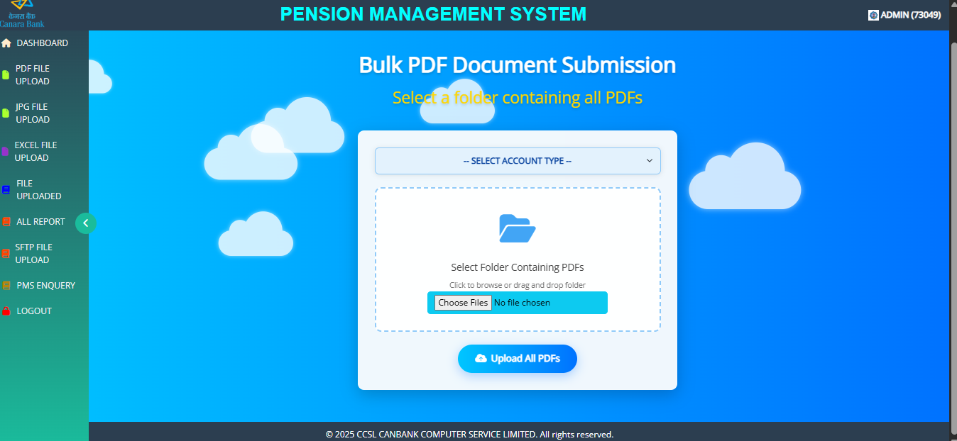

4. JPG/JPEG FILE UPLOAD

USER WILL CHOOSE JPG OR JPEG PHOTO’S FOLDER , ACCOUNTTYPE AND UPLOAD BUTTON
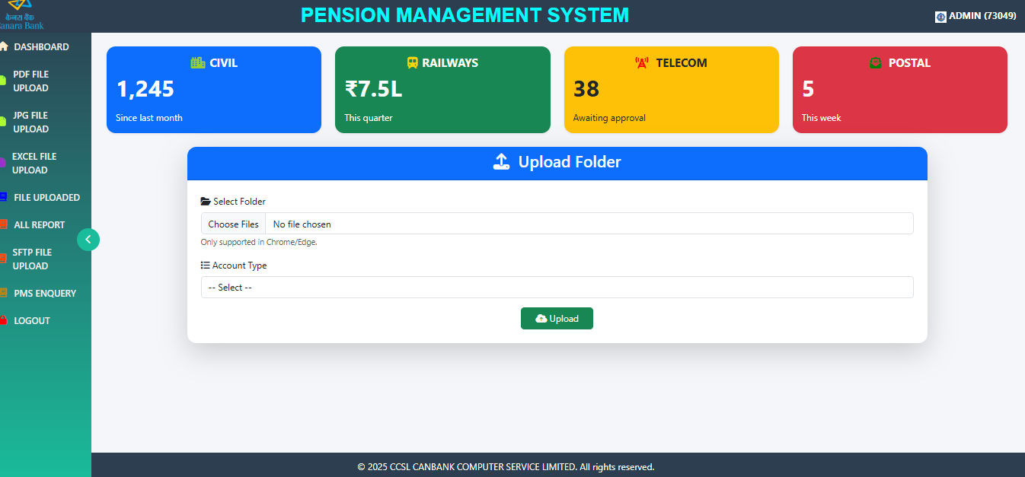

5.EXCEL FILE UPLAOD
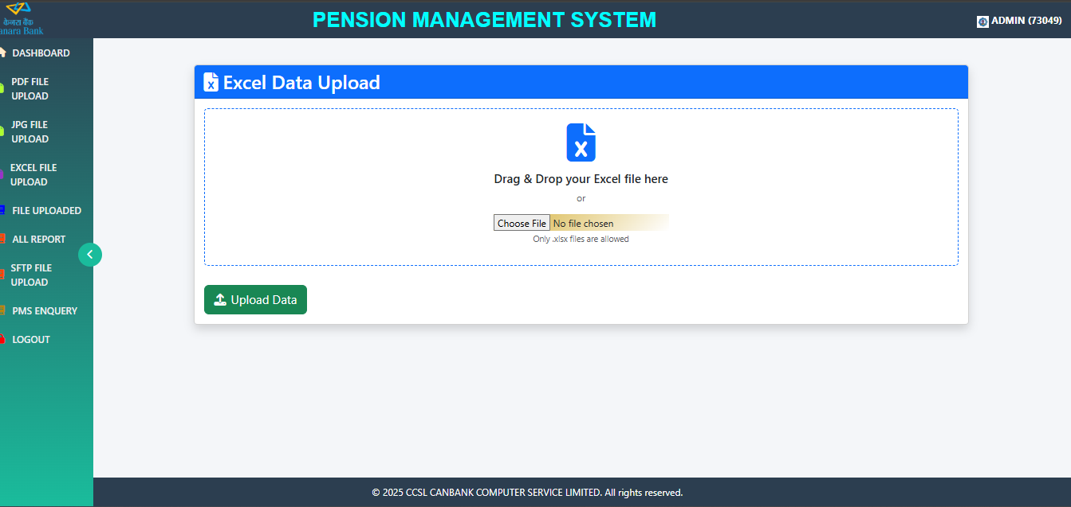
6. UPLOADED PDF AND JPG/JPEG FILE VIEW

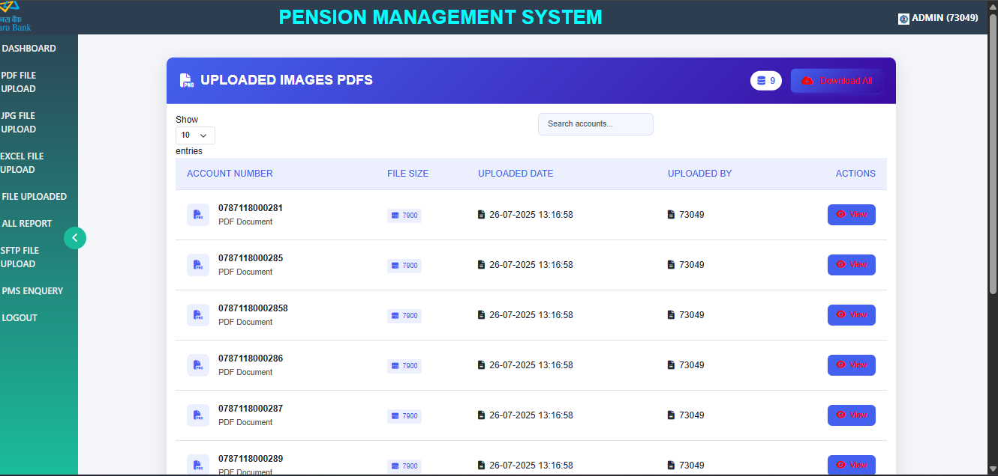

8. USER CAN DOWNLOAD BULK FILE IN ZIP :- WITH DOWNLAOD ALL OPTION
9. REPORT
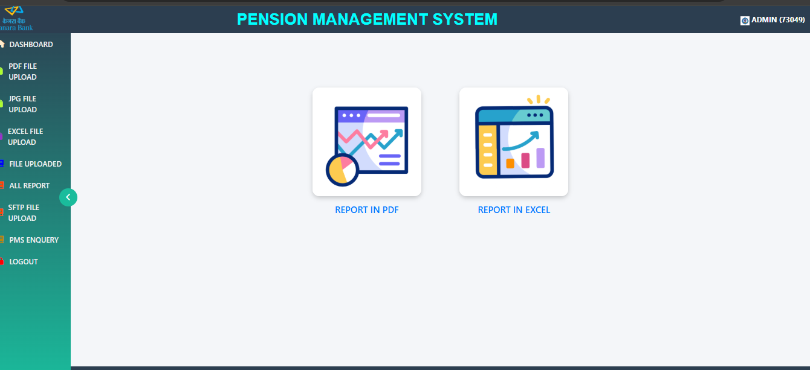

10. REPORT IN PDF FORMAT

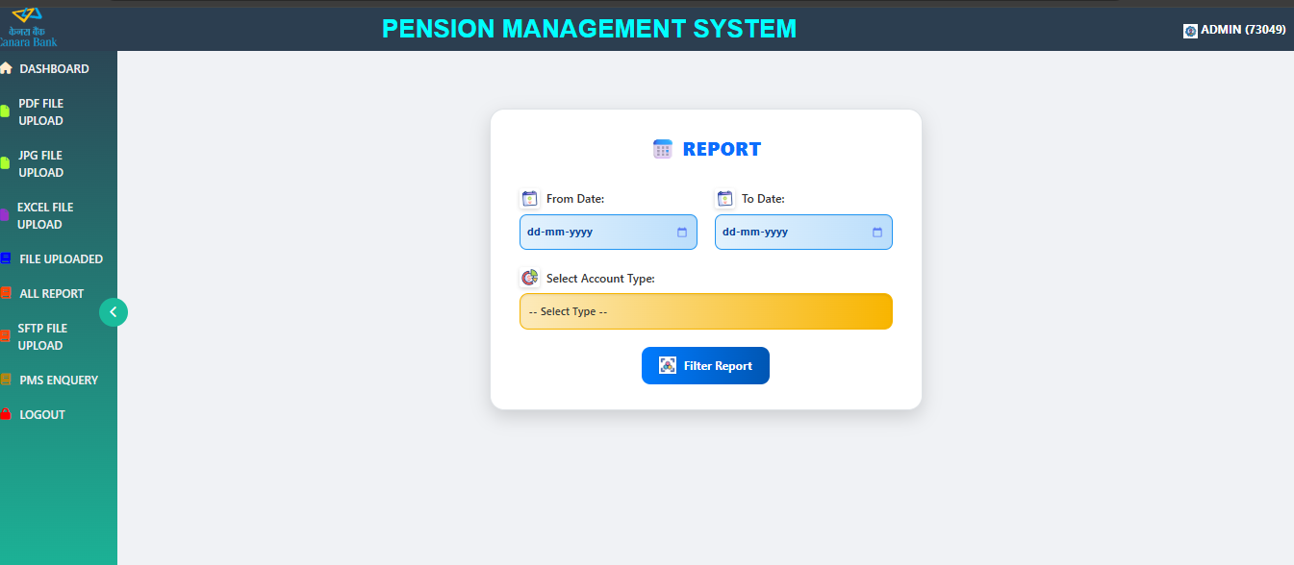

11. PDF REPORT SAMPLE
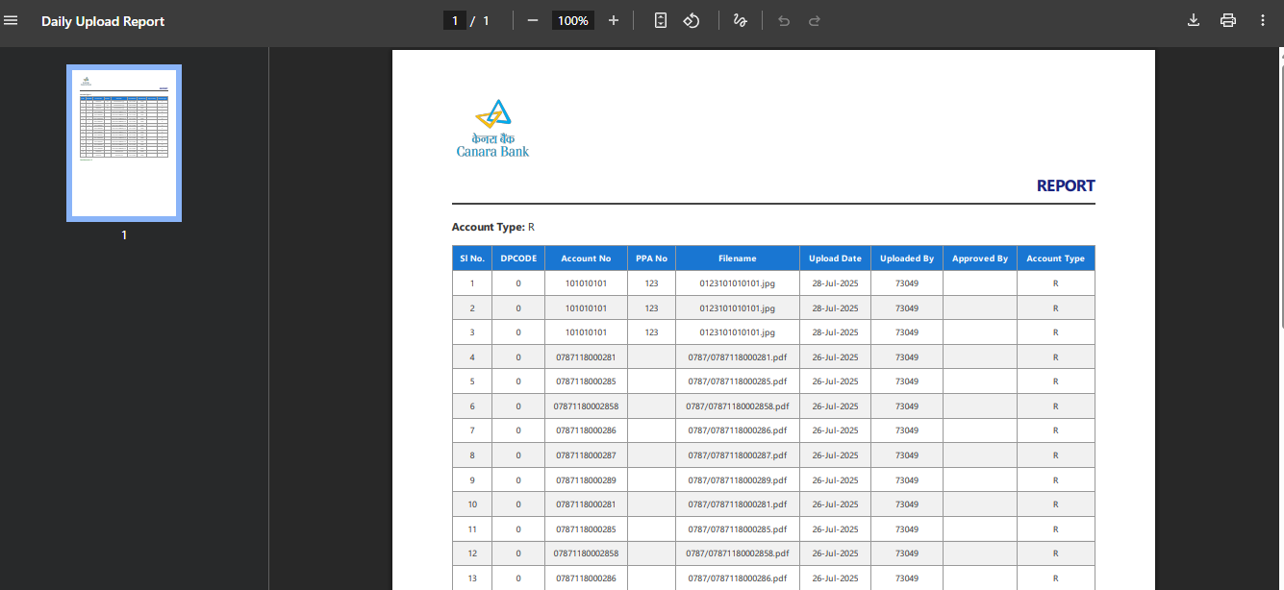
12. EXCEL REPORT SAMPLE
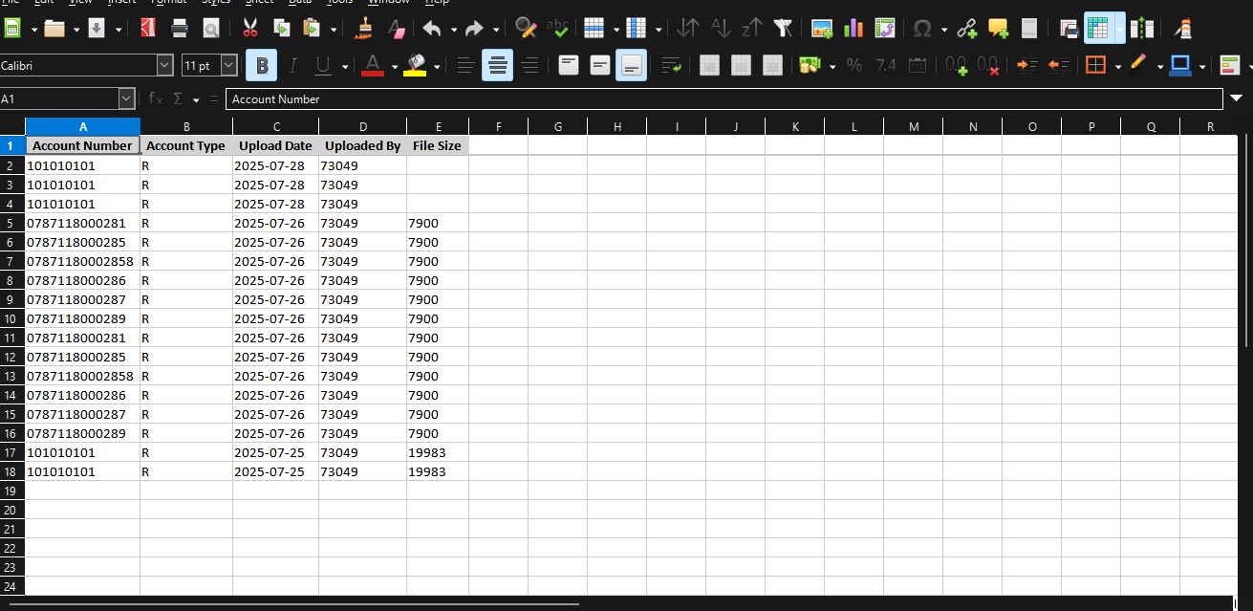

13. SFTP FILE UPLOAD

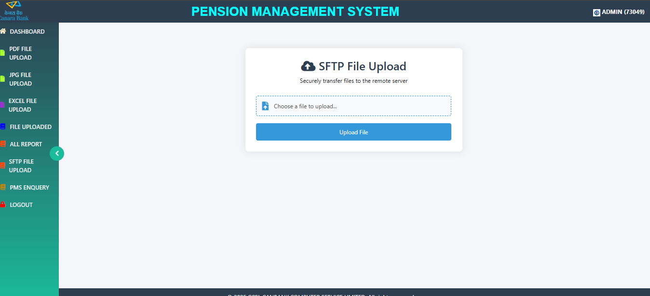

THANKS AND REGARDS
@CCSL TEAMS

